**Experiment 10**

**Aim:** Docker labels and Metadata.

**Procedure:**

**1)** To add a label on a container user option -l while launching container. For example, **docker run -l user=12345 -d redis**.  
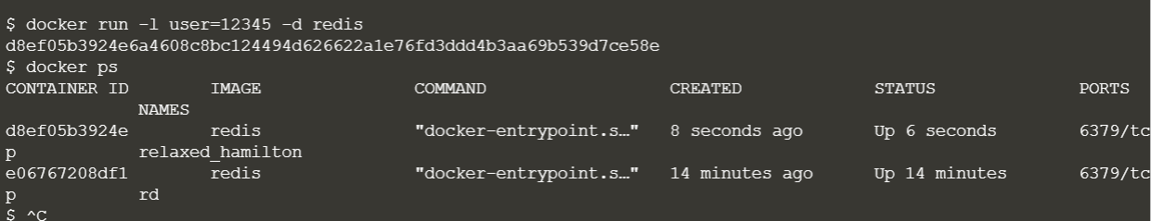

**2)** We can also add labels from external file. For this, using the **--label-file** option to provide file containing labels.  
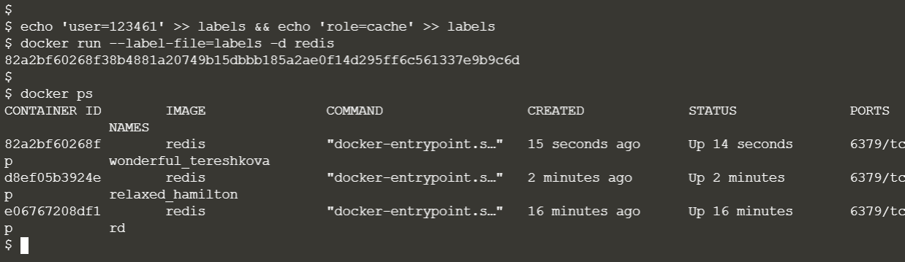

**3)** To see all the labels on a running container, use command **docker inspect**. But docker inspect will show other information as well.

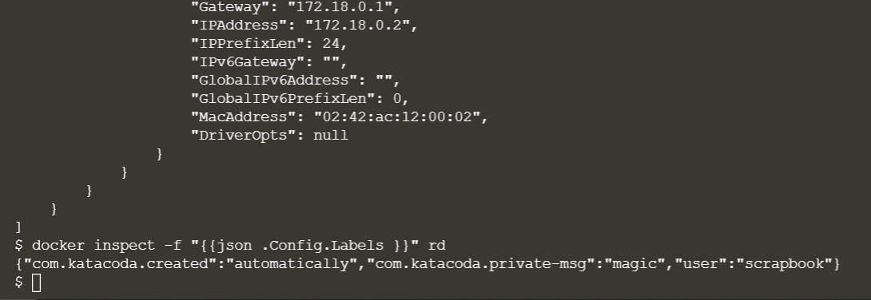

**4)** We can also see labels on images. For this command is **docker inspect -f "{{json .ContainerConfig.Labels }}" katacoda-label-example**.  
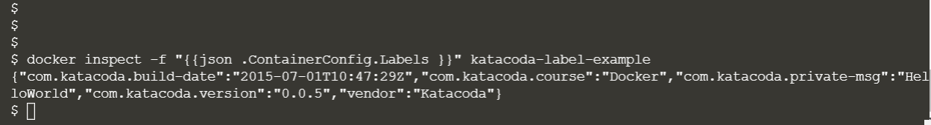

**5)** The command **docker ps** allows you to specify a filter based on a label name and value. For example, the query below will return all the containers which have a **user** label key with the value **katacoda**.  
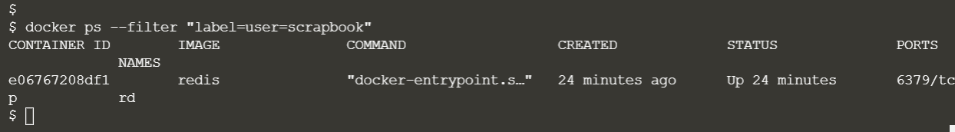

**6)** The same filter approach can be applied to images **based on the labels** used when the image was built.  
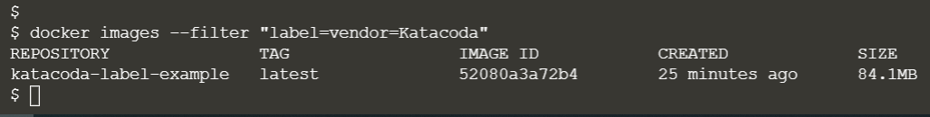

**Submitted by:**Arjun Rekhi

500068109

R171218028